1. **Access the application from container and check it**

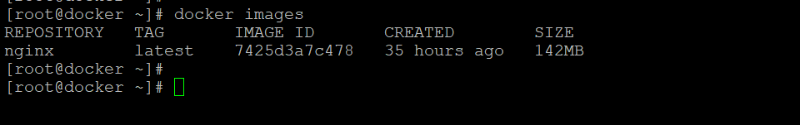



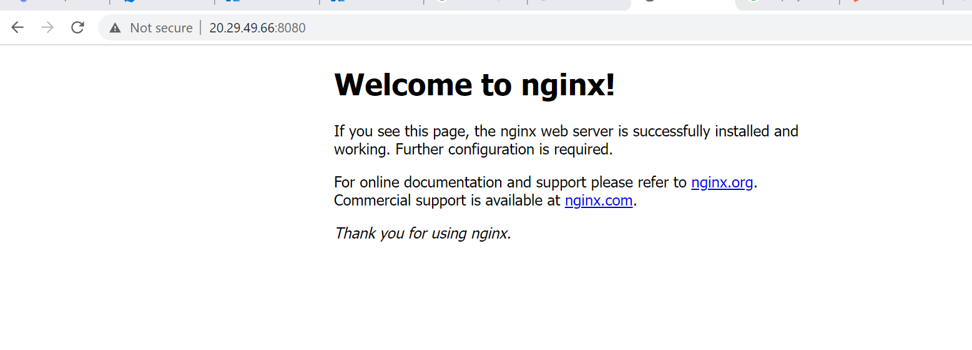

1. **Test the Dockerfile by running Docker build and create a container**

Create Dockerfile:-

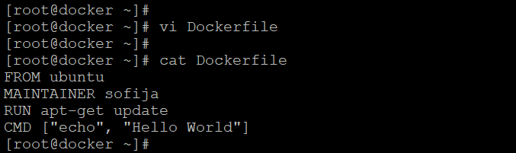

Docker Build :-

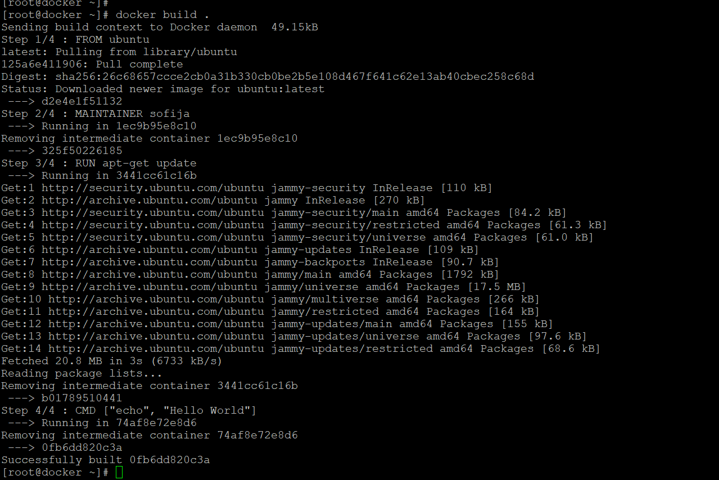

Docker images:-

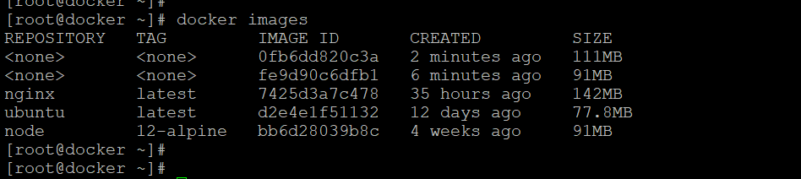

Docker Container:-

